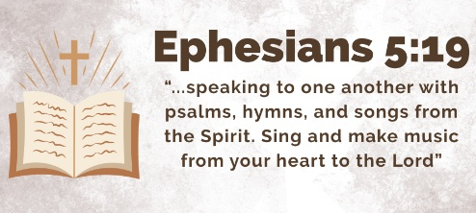
“Answering God’s Call”
June 28, 2026
Speaking Team

Colton McMillan
The Law of Human Nature

God Explains Human Morality

Christianity is Not Just About “Being Good”

So What Does This Mean?

Chris Hess

Natalia Martinez

“Answering God’s Call”
June 28, 2026
Speaking Team

Colton McMillan
The Law of Human Nature

God Explains Human Morality

Christianity is Not Just About “Being Good”

So What Does This Mean?

Chris Hess

Natalia Martinez

