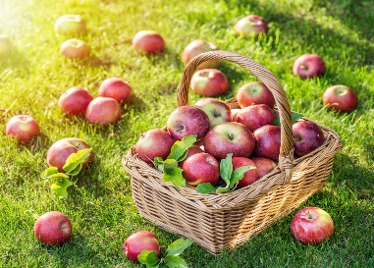***“Steps To A Fruitful Harvest – The Story Of Deborah”***

***August 21, 2022***

***Pastor Bear Clifton***

Where we’ve come in our summer series, and what’s next:

Background to the book of Deborah:

***4 Ministry Lessons From The Story Of Deborah***

* I need to understand why my ministry is _________________.
* I need to understand what I _________________ _______________ in ministry.
* I need to understand the __________ of ministry.
* I need to understand the ________________ of ministry.

*What Are Our Next Steps?*